**JAVASCRIPT ASSIGNMENT**

**1.Write a JavaScript function to find the intersection of two arrays.**

<https://codeshare.io/1Y8rwq>

**2.Write a JavaScript program to sort an array of objects based on a specified property.**

<https://codeshare.io/xv4mWd>

**3.Write a JavaScript program to find the sum of all numbers in an array.**

<https://codeshare.io/4eoNy7>

**4.Write a JavaScript function to find the nth largest element in an array.**

<https://codeshare.io/MNE86y>

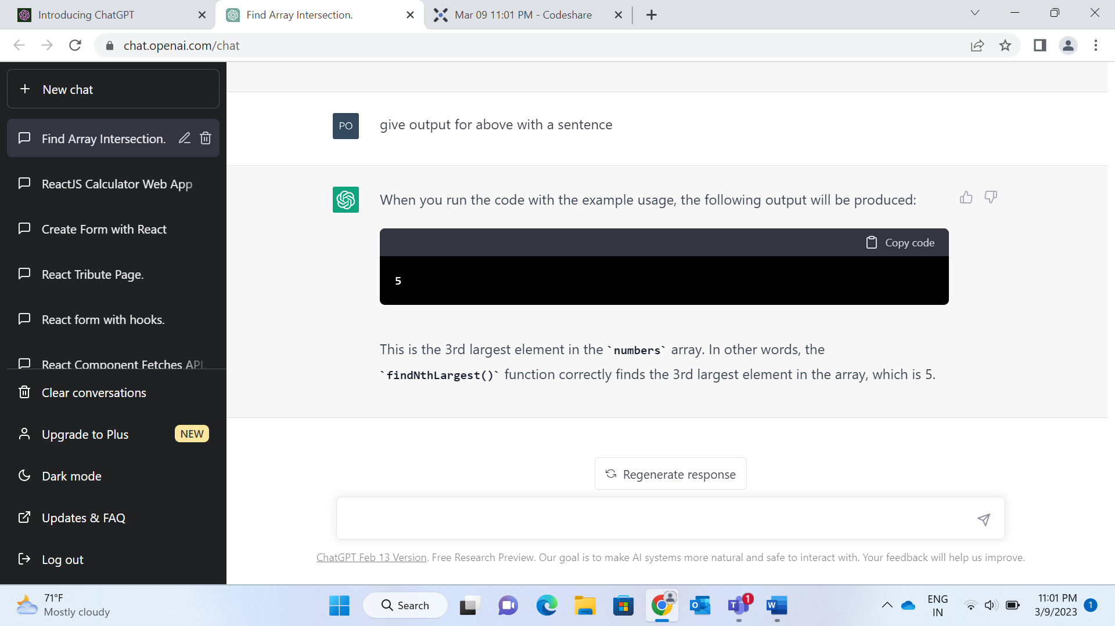

**5.Write a JavaScript program to implement a binary search algorithm.**

<https://codeshare.io/X8Ejkz>

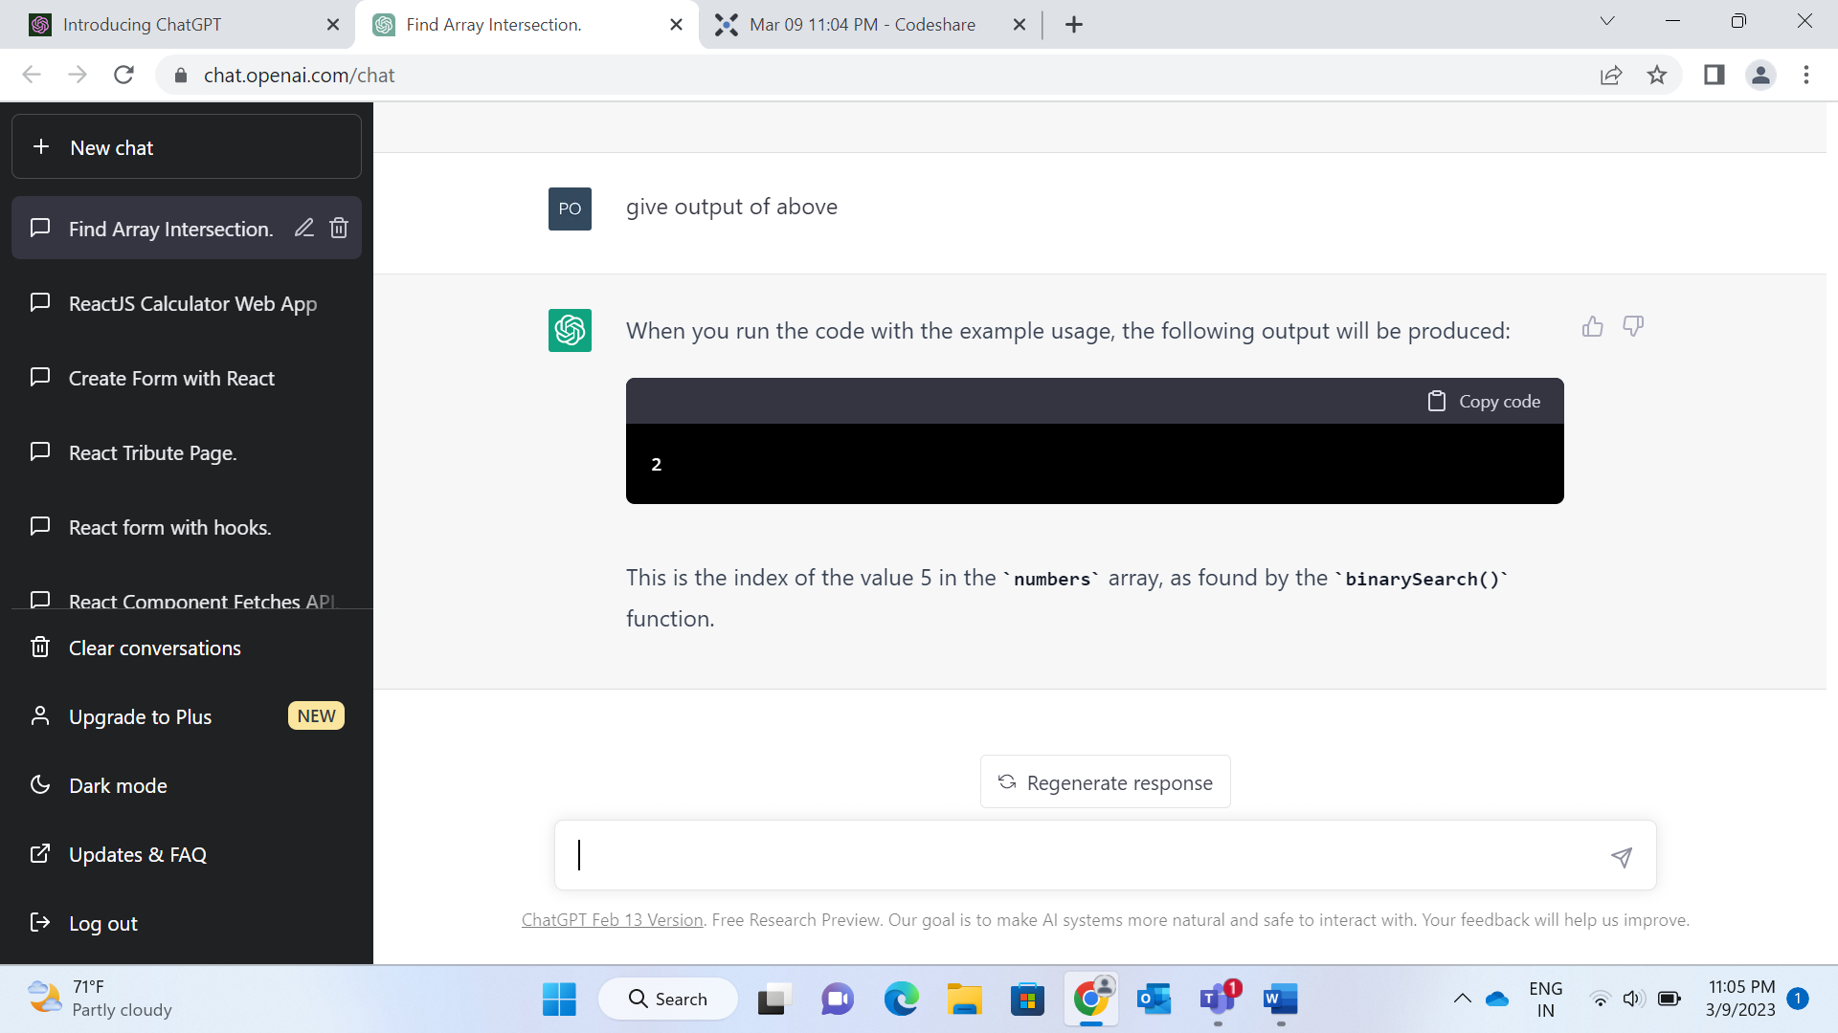

**6.Write a JavaScript program to reverse the order of words in each string.**

<https://codeshare.io/0gvLY8>

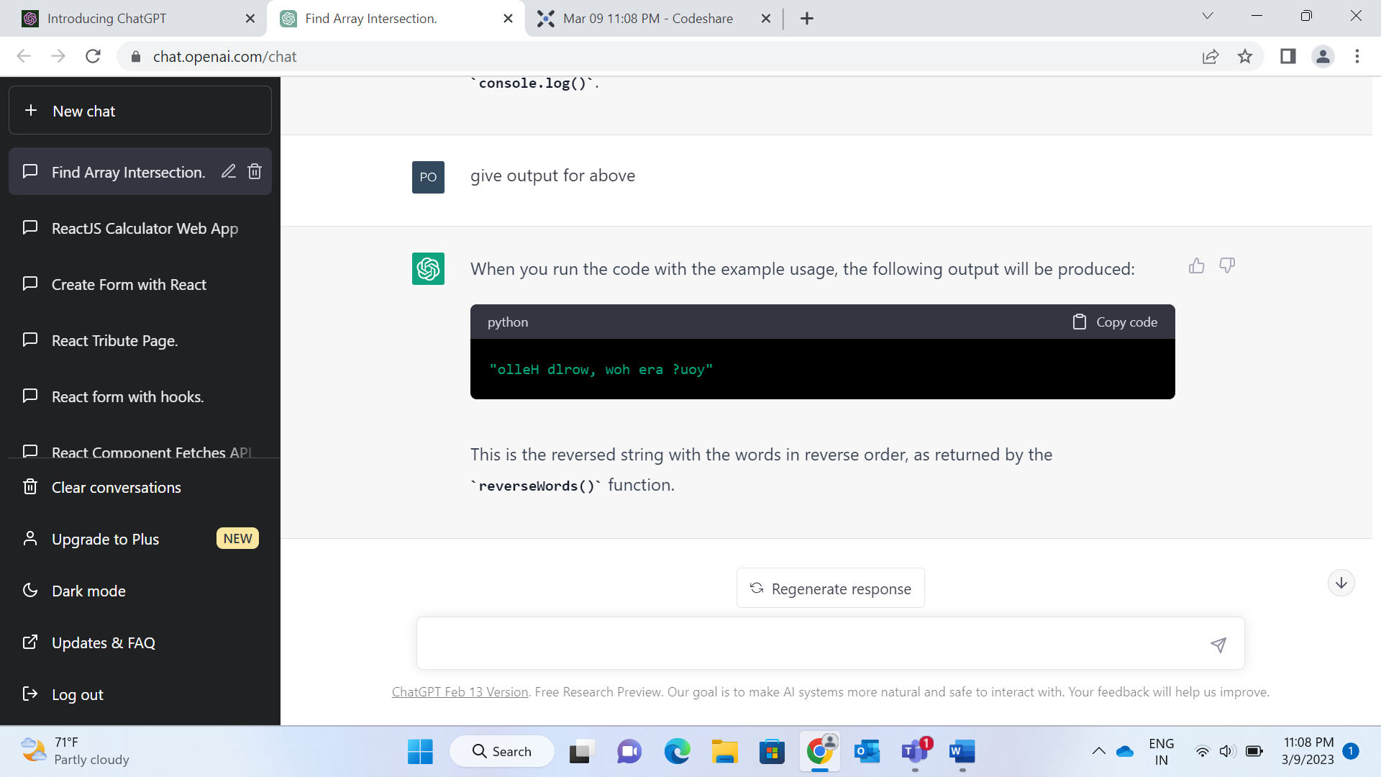

**7.Write a JavaScript function to implement a bubble sort algorithm.**

<https://codeshare.io/WdEyxM>

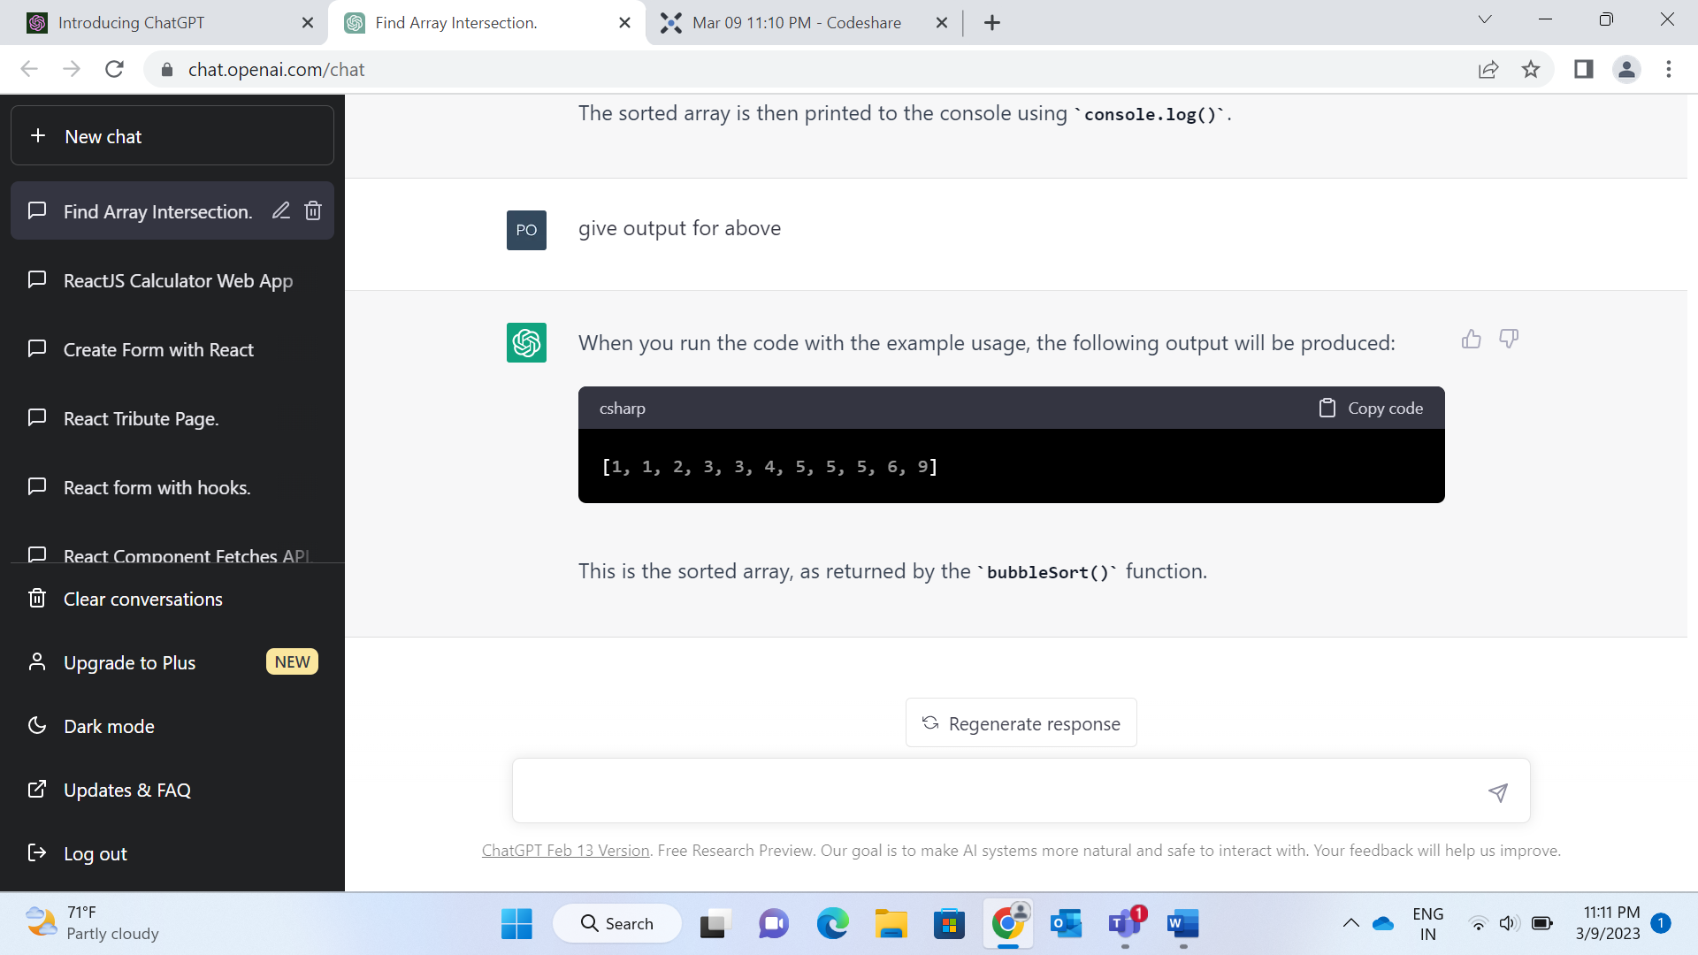

**8.Write a JavaScript program to find the missing number in an array of integers.**

<https://codeshare.io/JbMe0X>

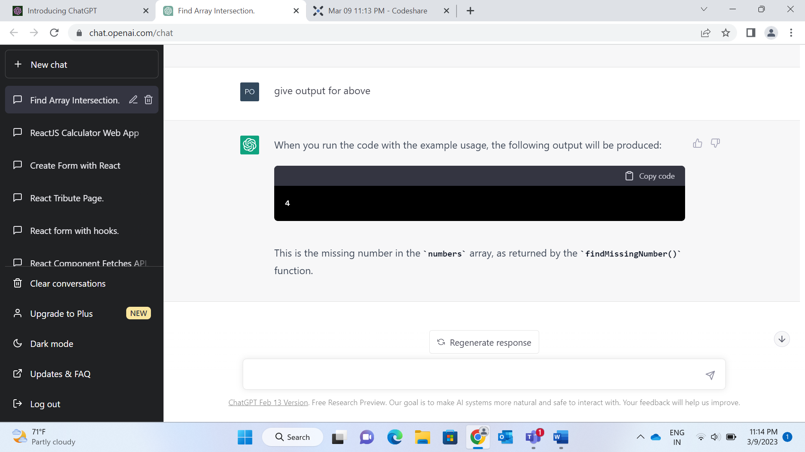

**9.Write a JavaScript function to find the first non-repeating character in each string.**

<https://codeshare.io/8pl19A>

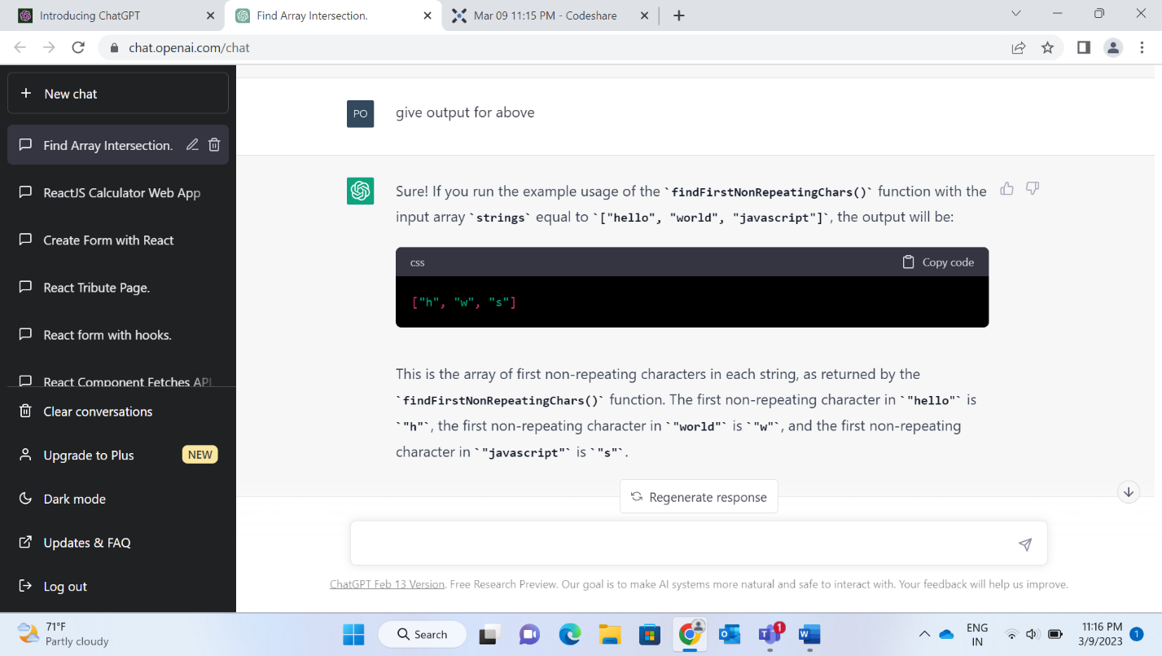

**10.Write a JavaScript program to implement a merge sort algorithm.**

<https://codeshare.io/LwEdNg>

